**ggplot2**

**Grammar of Graphics**

2 principles

1. Graphics = distinct layers of grammatical elements
2. Meaningful plots through aesthetic mapping

|  |  |
| --- | --- |
|  |  |

ggplot(mtcars, aes(x = wt, y = mpg)) + geom_point()

ggplot(mtcars, aes(x = wt, y = mpg, **color** = disp)) + geom_point()

ggplot(mtcars, aes(x = wt, y = mpg, **size** = disp)) + geom_point()

|  |  |
| --- | --- |
|  |  |

**Data**

iris.wide (pg15) & iris.tidy (pg23) & facet_grid()

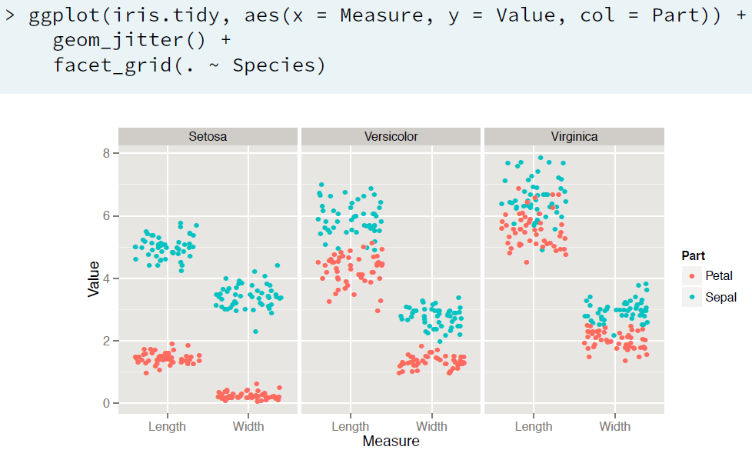

**Aesthetics**

* Column can be mapped onto visible ***aesthetic***
* Aesthetics in aes(), ***attributes*** in geom_(col=”red”)
* aes() can also be called in geom_(), but done usually when you want to include multiple data sources
* ggplot(mtcars, aes(x=wt, y=mpg, fill=cyl, col=am)) + geom_point(shape=21, size=4, alpha=0.6)
  + aes has to be associated with columns
  + attributes are given along with geom_*() and don’t have columns associated with them
* ggplot(mtcars, aes(x = wt, y = mpg, fill = cyl, label=rownames(mtcars))) + geom_text(color='red')
* **Modifying Aesthetics**
  + geom_bar(**postion**=”< stack, fill, dodge, … >”)
  + **scale_\*** functions
    - scale_x/y_continuous/discrete(“title”, limits, breaks, expand, ….)
  + **labs**(x,y,col, …)

|  |  |
| --- | --- |
| Aesthetics for Continuous Variables | Aesthetics for Categorical Variables |